…One of the fun bits of my job is that I have actual time dedicated to helping colleagues and grad students with statistical or computational problems. Recently I’ve been helping one of our Lab Instructors with some data that from their Plant Physiology Lab course. Whilst I was writing some R code to import the raw data for the lab from an Excel sheet, it occurred to me that this would be a good excuse to look at the new pivot_longer() and pivot_wider() functions from the *tidyr* package. In this post I show how these new functions facilitate common data processing steps; I was personally surprised how little data wrangling was actually needed in the end to read in the data from the lab.

In the lab course the students conduct an experiment to study the effect of the plant hormone *gibberellin* on plant growth. Over a number of weeks the students apply gibberellic acid (in two concentrations) or daminozide, a gibberellic acid antagonist, to the tips of the leaves of pea plants that are grown in a growth chamber with a 16-hour photoperiod. The students work in groups, with some of the groups growing the wild- type cultivar, whilst others work with a mutant dwarf cultivar. Each group has six plants per treatment level, and every seven days the students measure the height of each plant and the number of internodes that each plant has. On the last day of the experiment the plants are harvested and their fresh weight measured.

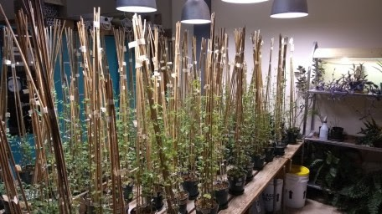

The pea plants from the 2019 Plant Physiology Lab course, toward the end of the experimental period

Originally the data were recorded in a less than satisfactory way — let’s just say the original data sheets would have been good candidates for one of Jenny Bryan’s talks on spreadsheets. After being cleaned up a bit, we have something that looks like this in Excel

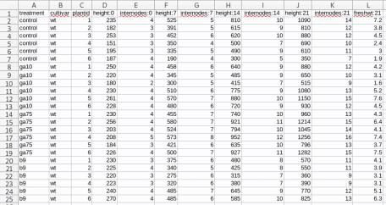

Raw data in the Excel Workbook

This isn’t perfect as we have data in the column names — the numbers after the colons are the day of observation — but it is a pretty simple layout for the students to complete, and this is how we decided to ask the students to record the data during the 2019 lab course, so this is what we have to work with going forward.

Ultimately we want to be able to refer to columns named height, internodes, etc depending on the

statistical analysis the students will do, and we’re going to need a column with the observation days in it.

**Pivoting**

If you’re not familiar with pivoting, it is important to realize that we can store the same data in a wide rectangle or a long (or tall) rectangle

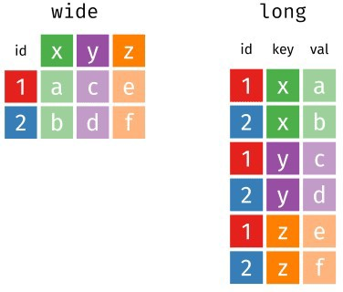

Examples of *wide* and *long* representations of the same data. Source: Garrick Aden-Buie’s ((**???**)) Tidy Animated Verbs

The same information is stored in both the long and wide representations, but the two representations differ in how useful they are for certain types of operation or how easily they can be used in a statistical analysis. It’s also worth noting that there are more than just long or wide representations of the data; as we’ll see shortly, the long representation of the Plant Physiology Lab data is too general and we’ll need to arrange the data in a slightly wider form.

Moving between long and wide representations is known as *pivoting*. The animation below show the general idea of how the cells in one format are rearranged into the other format, with the relevant metadata that doesn’t get rearranged being extended or reduced as needed so we don’t loose any information.

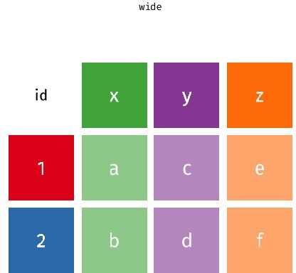

Pivoting between *wide* and *long* representations of the same data. Source: Garrick Aden-Buie’s ((**???**)) Tidy Animated Verbs modified by Mara Averick ((**???**))

With the lab data I showed earlier, we’re going to need to pivot from the original wide format into a longer format — just as the animation above shows. As we want to output an object that is *longer* than the input we will use the pivot_longer() function.

To start we will need to import the data from the .xls sheet, which I’ll do using the *readxl* package

library('curl') # download files library('readxl') # read from Excel sheets library('tidyr') # data processing library('dplyr') # mo data processing library('forcats') # mo mo data processing library('ggplot2') # plotting theme_set(theme_bw())

## Load Data

tmp <- tempfile()

curl_download("https://github.com/gavinsimpson/plant-phys/raw/master/f18ph.xls", tmp) plant <- read_excel(tmp, sheet = 1)

We have to download the data first — which I do using curl_download() from the *curl* package — because read_excel() doesn’t currently know how to read from URLs at the moment.

Now we have our plant data within R, stored in a data frame

plant

# A tibble: 24 x 12

|  |  |  |  |  |  |
| --- | --- | --- | --- | --- | --- |
| treatment | cultivar | plantid | `height:0` | `internodes:0` | `height:7` |
| 1 control | wt | 1 | 235 | 4 | 525 |
| 2 control | wt | 2 | 182 | 3 | 391 |
| 3 control | wt | 3 | 253 | 3 | 452 |
| 4 control | wt | 4 | 151 | 3 | 350 |

1. control wt 5 195 3 335
2. control wt 6 187 4 190

7 ga10 wt 1 250 4 458

8 ga10 wt 2 220 4 345

9 ga10 wt 3 180 2 300

10 ga10 wt 4 230 4 510

# … with 14 more rows, and 6 more variables: `internodes:7` , # `height:14` , `internodes:14` , `height:21` ,

# `internodes:21` , `freshwt:21`

To go to the long representation we have to tell pivot_longer() a couple of bits of information

the name of the object to pivot,

which columns contain the data we want to pivot (or alternatively which columns not to pivot if that is easier),

the *name* we want to call the new column that will contain the *variable name* information from the original data, and

optionally, the name of the new column that will contain the data values. The default is to name this column value so you don’t need to change this if you’re happy with that.

So, to get our wide plant data into a longer format we would do this

pivot_longer(plant, -(1:3), names_to = "variable") # A tibble: 216 x 5

treatment cultivar plantid variable value

|  |  |  |  |  |  |
| --- | --- | --- | --- | --- | --- |
| 1 control | wt |  | 1 | height:0 | 235 |
| 2 control | wt |  | 1 | internodes:0 | 4 |
| 3 control | wt |  | 1 | height:7 | 525 |
| 4 control | wt |  | 1 | internodes:7 | 5 |
| 5 control | wt |  | 1 | height:14 | 810 |
| 6 control | wt |  | 1 | internodes:14 | 10 |
| 7 control | wt |  | 1 | height:21 | 1090 |
| 8 control | wt |  | 1 | internodes:21 | 14 |
| 9 control | wt |  | 1 | freshwt:21 | 7.2 |
| 10 control | wt |  | 2 | height:0 | 182 |
| # … with 206 | more | rows |  |  |  |

The -(1:3) is short-hand for excluding the first three columns of plant from the pivot. Here, we’re creating a new variable called (imaginatively!) variable. As you can see we now have our data in a much longer representation, with a single column containing all of the observations that this group of students made.

However, we have a bit of a problem: we have the added complication that some of the column names contain actual data that we want to use. While we have a column containing this information — it is not lost

— the observation day or variable name information is not directly accessible in this format. What we could do is split the strings in this new variable column on “:” and form two new columns from there.

Thankfully, this is such a common operation that pivot_longer() (and it’s predecessor, gather()) can do this for you — all you have to do is tell pivot_longer() what character to split on, and what names you want for the columns that result from splitting the strings up.

pivot_longer(plant, -(1:3), names_sep = ":", names_to = c("variable","day"))

# A tibble: 216 x 6

treatment cultivar plantid variable day value

|  |  |  |  |  |  |
| --- | --- | --- | --- | --- | --- |
| 1 control | wt | 1 | height | 0 | 235 |
| 2 control | wt | 1 | internodes | 0 | 4 |

|  |  |  |  |  |  |  |
| --- | --- | --- | --- | --- | --- | --- |
| 3 control | wt |  | 1 | height | 7 | 525 |
| 4 control | wt |  | 1 | internodes | 7 | 5 |
| 5 control | wt |  | 1 | height | 14 | 810 |
| 6 control | wt |  | 1 | internodes | 14 | 10 |
| 7 control | wt |  | 1 | height | 21 | 1090 |
| 8 control | wt |  | 1 | internodes | 21 | 14 |
| 9 control | wt |  | 1 | freshwt | 21 | 7.2 |
| 10 control | wt |  | 2 | height | 0 | 182 |
| # … with 206 | more | rows |  |  |  |  |

The changes we made above were to specify names_sep with the correct separator, and we pass a vector of new column names to names_to rather than the single name we provided previously.

Those of you with good eyes may have noticed another problem that we will encounter if we stopped here. The day variable that was just created is stored as a character vector. It is likely that we’ll want this information stored as a number if we’re going to analyze the data. We can do the required conversion within pivot_longer() call by specifying what the developers have started calling a *prototype* across many of the *tidyverse* packages. A prototype is an object that has the same properties that you want objects built from that prototype to take. Here we want the day variable as a column of integer numbers, so we set the prototype for this vector to integer() using the names_ptypes argument

plant <- pivot_longer(plant, -(1:3), names_sep = ":", names_to = c("variable","day"),

names_ptypes = list(day = integer()))

plant

# A tibble: 216 x 6

treatment cultivar plantid variable day value

|  |  |  |  |  |  |  |
| --- | --- | --- | --- | --- | --- | --- |
| 1 control | wt |  | 1 | height | 0 | 235 |
| 2 control | wt |  | 1 | internodes | 0 | 4 |
| 3 control | wt |  | 1 | height | 7 | 525 |
| 4 control | wt |  | 1 | internodes | 7 | 5 |
| 5 control | wt |  | 1 | height | 14 | 810 |
| 6 control | wt |  | 1 | internodes | 14 | 10 |
| 7 control | wt |  | 1 | height | 21 | 1090 |
| 8 control | wt |  | 1 | internodes | 21 | 14 |
| 9 control | wt |  | 1 | freshwt | 21 | 7.2 |
| 10 control | wt |  | 2 | height | 0 | 182 |
| # … with 206 | more | rows |  |  |  |  |

Notice that we pass names_ptypes a *named* list of prototypes, with the list name matching one or more of the variables listed in names_to.

Now we have successfully wrangled the data into a long format and recovered the information hidden in the column names of the original data file. However, as it stands, we can’t easily use the data in this format in a statistical model. We want the students on the course to analyze the data to estimate what effects the treatments have on the height of the plants over the course of the experiment. With the data in this long format we don’t have a variable height containing just the height of the plants that we can refer to in a linear model say.

What we want is to create new columns for height, internodes and freshwt and pivot the value data out into those columns. As we’re adding columns we’re making the data wider, so we can use the pivot_wider() function to do what we want. Now we need to tell pivot_wider()

where to take the *names* of the new variables that are going to be created **from** — here that’s the

variable column, and

where to take the *data* values **from** that are going to be put into these new columns — here, that’s the

value column

plant <- pivot_wider(plant, names_from = variable, values_from = value)

plant

# A tibble: 96 x 7

treatment cultivar plantid day height internodes freshwt

|  |  |  |  |  |  |  |  |
| --- | --- | --- | --- | --- | --- | --- | --- |
| 1 control | wt |  | 1 | 0 | 235 | 4 | NA |
| 2 control | wt |  | 1 | 7 | 525 | 5 | NA |
| 3 control | wt |  | 1 | 14 | 810 | 10 | NA |
| 4 control | wt |  | 1 | 21 | 1090 | 14 | 7.2 |
| 5 control | wt |  | 2 | 0 | 182 | 3 | NA |
| 6 control | wt |  | 2 | 7 | 391 | 5 | NA |
| 7 control | wt |  | 2 | 14 | 615 | 9 | NA |
| 8 control | wt |  | 2 | 21 | 810 | 12 | 3.8 |
| 9 control | wt |  | 3 | 0 | 253 | 3 | NA |
| 10 control | wt |  | 3 | 7 | 452 | 6 | NA |
| # … with 86 | more | rows |  |  |  |  |  |

As with other *tidyverse* package, we don’t have to quote the names of the columns we want to pull data from. There are a couple of other things we need to do to make the data fully useful:

1. it would be helpful to have a unique identifier for each individual plant — currently the plantid is just the values 1:6 repeated for each treatment group,
2. it would also be good practice to convert treatment into a factor, and to set the control treatment as the reference level against which the other treatment levels will be compared — if we didn’t do that, the b9 level (daminozide treatment) would be the reference level

We can do those data processing steps quite easily now we have the data imported and arranged nicely the way we want them

plant <- mutate(plant,

id = paste0(cultivar, "_", treatment, "_", plantid), treatment = fct_relevel(treatment, 'control'))

plant

# A tibble: 96 x 8

treatment cultivar plantid day height internodes freshwt id

|  |  |  |  |  |  |  |
| --- | --- | --- | --- | --- | --- | --- |
| 1 control  wt_control_1 | wt | 1 | 0 | 235 | 4 | NA |
| 2 control | wt | 1 | 7 | 525 | 5 | NA |
| wt_control_1 |  |  |  |  |  |  |
| 3 control | wt | 1 | 14 | 810 | 10 | NA |
| wt_control_1 |  |  |  |  |  |  |
| 4 control | wt | 1 | 21 | 1090 | 14 | 7.2 |
| wt_control_1 |  |  |  |  |  |  |
| 5 control | wt | 2 | 0 | 182 | 3 | NA |
| wt_control_2 |  |  |  |  |  |  |
| 6 control | wt | 2 | 7 | 391 | 5 | NA |
| wt_control_2 |  |  |  |  |  |  |
| 7 control | wt | 2 | 14 | 615 | 9 | NA |
| wt_control_2 |  |  |  |  |  |  |
| 8 control | wt | 2 | 21 | 810 | 12 | 3.8 |
| wt_control_2 |  |  |  |  |  |  |
| 9 control wt | | 3 | 0 | 253 | 3 | NA |
| 10 control wt | | 3 | 7 | 452 | 6 | NA |

wt_control_3

wt_control_3

# … with 86 more rows

Here I just pasted together the cultivar, treatment and plantid information into a unique id for each individual plant. This won’t be used directly by the students in any analysis they do as this is a second year course and they don’t know about mixed models (yet), but it is handy to have this id available for plotting. The treatment variable is converted to a factor and the reference level set to be “control” using the fct_relevel() function from the *forcats* package.

The students will do one other step before proceeding to look at the data — each sheet in the .xls file contains observations from a single group and hence a single cultivar, and we want the students to compare cultivars. So they will repeat the steps above to import a second sheet of data containing data from the cultivar they didn’t work with, and then stick the two data sets together. But I’ll spare you having to repeat that.

If you’re interested, this is what the data look like, for a single cultivar and single group

ggplot(plant, aes(x = day, y = height, group = id, colour = treatment)) +

geom_point() + geom_line() +

labs(y = 'Height (mm)', x = 'Day', colour = 'Treatment')

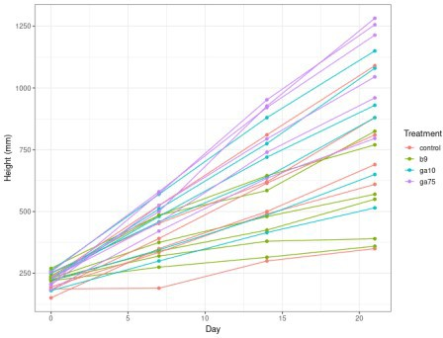

Plot of the plant growth data

(and now you can see why I needed a unique plant identifier even though the students will essentially ignore this clustering in the data when the analyse it.)

The .xls file we downloaded at the start of the script contains multiple sheets all formatted the same way, so we could pull in all the data into one big analysis if you wanted, but in the lab we’re just getting the students one set of wild-type and mutant cultivars.

.